**EPL425:**

**PLOTS AND SCREENSHOTS FOR ASSIGNMENT 1**

**Evangelos Papadopoulos , Andreas Iacovou**

**1CORE MEASUREMENTS:**

-300 requests, 1 user, 1 CPU, 3000 max repetitions:

Throughput: 0.6820473281537275 requests/second

Latency: 1464.3367 milliseconds

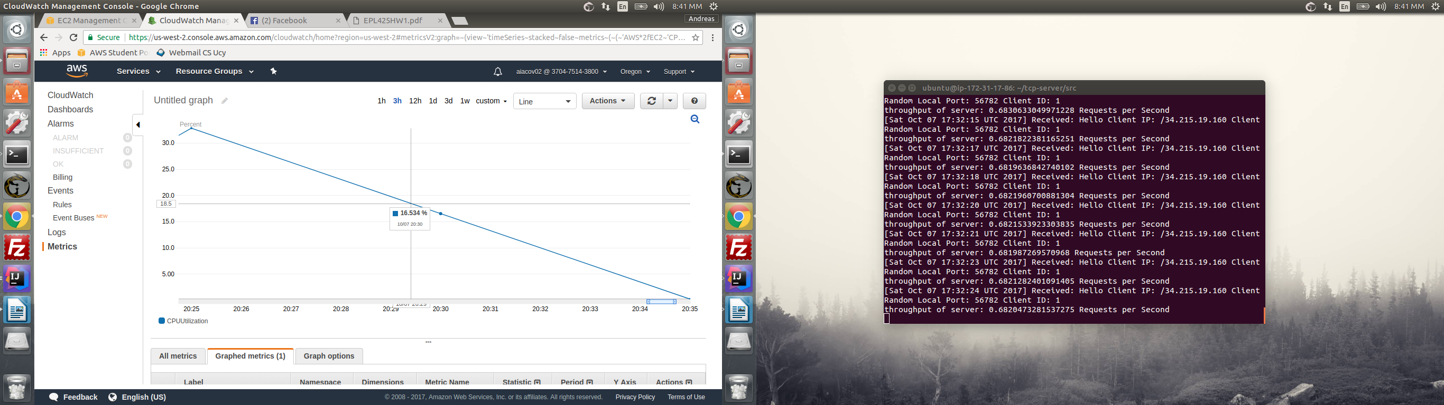CPU: 16.534%

-300 requests, 2 users, 1 CPU, 3000 max repetitions – 8:46pm:

Throughput 0.9667714674913007 Requests per Second

Latency: 2059.2617 milliseconds

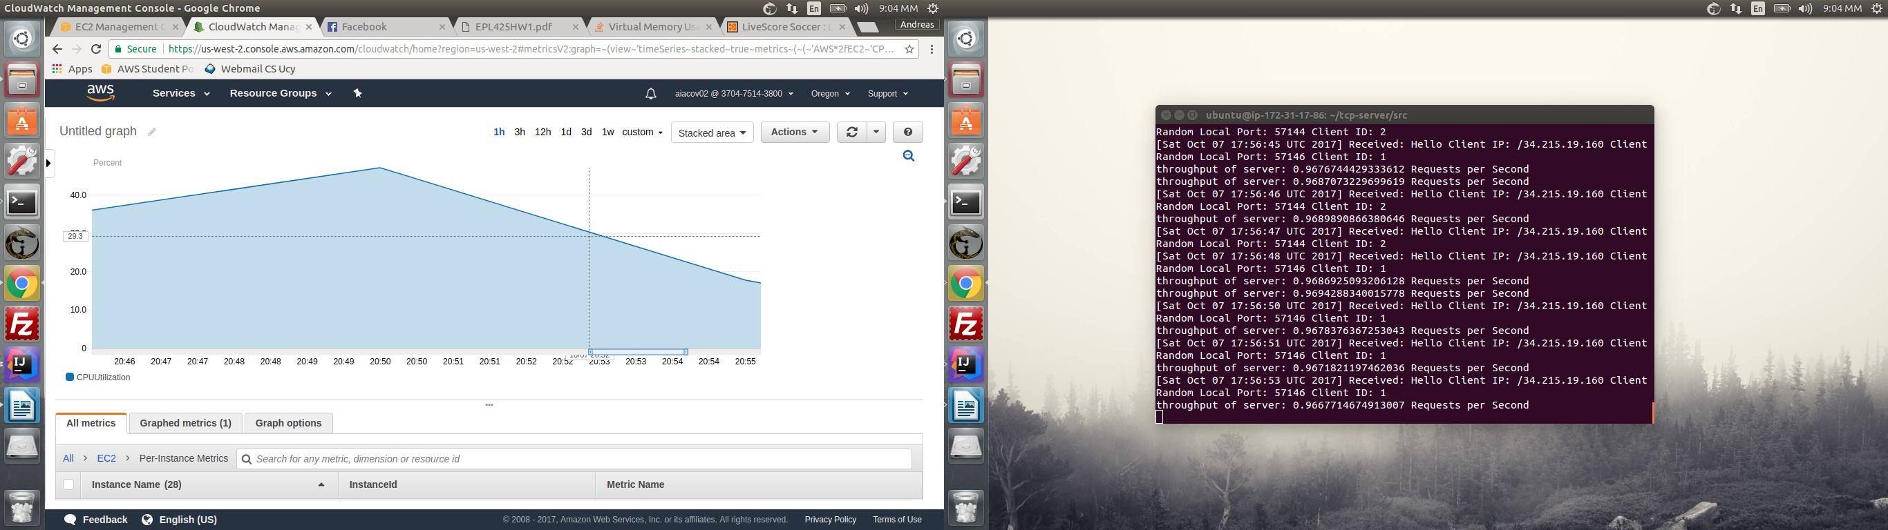CPU: 29.1%

-300 requests, 5 users, 1 CPU, 3000 max repetitions – 9:05pm:

Throughput 1.022731381888171 Requests per Second

Latency: 4815.2295 milliseconds

CPU: 48.362%

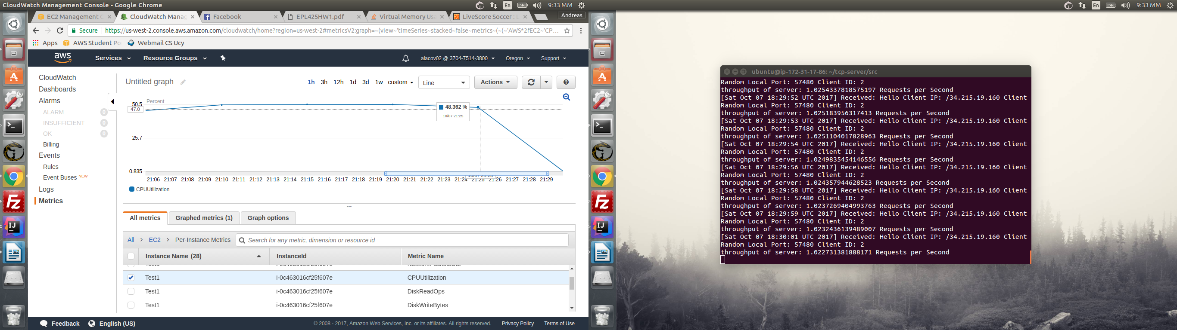

-300 requests, 10 users, 1 CPU, 3000 max repetitions – 9:37pm:

throughput of server: 0.5928781476264611 Requests per Second

Latency: 14005.24 milliseconds

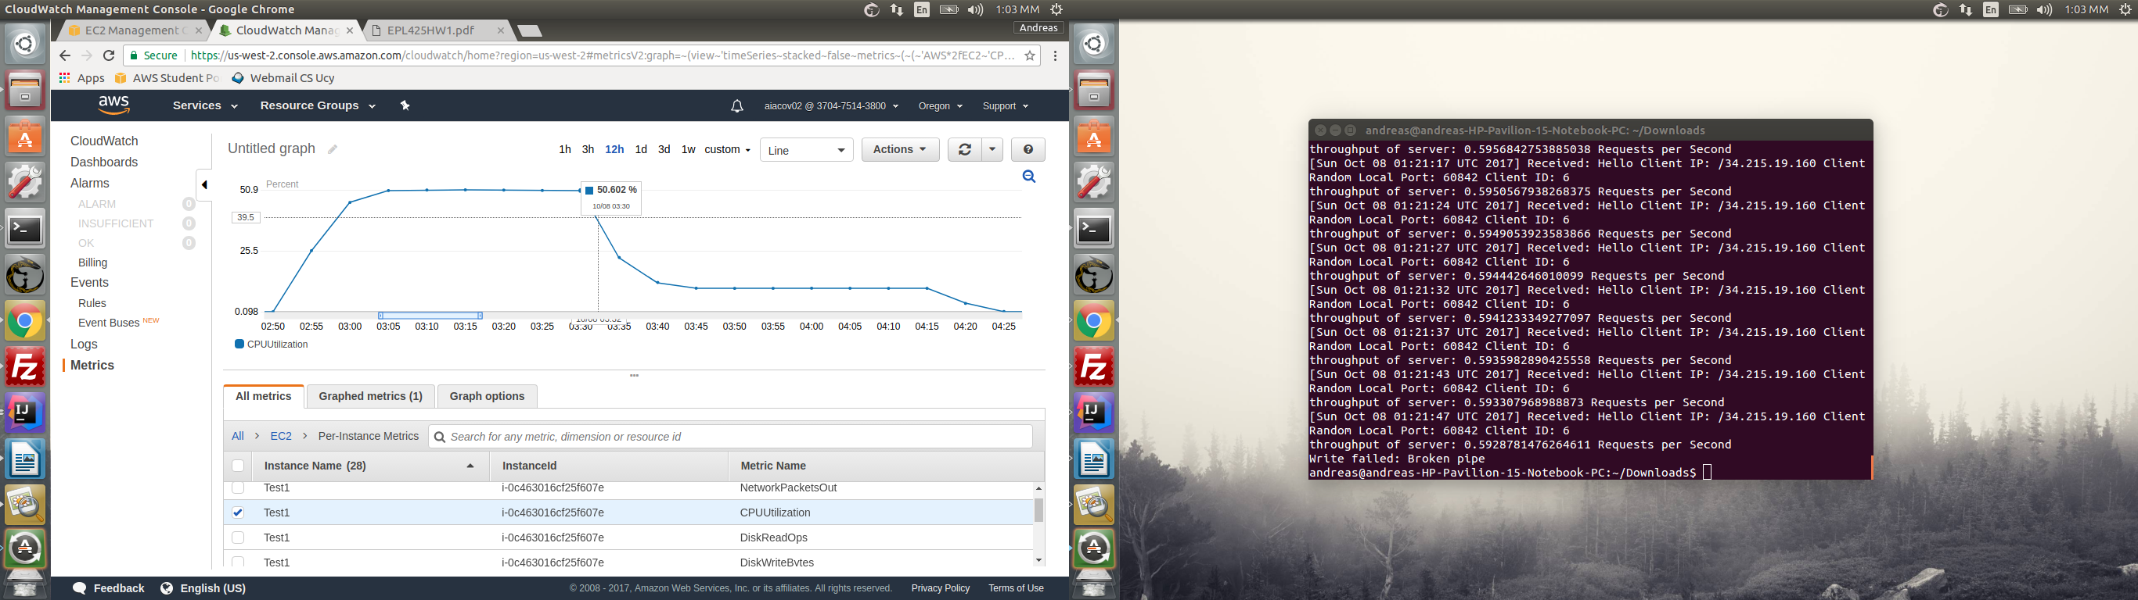CPU: 50.632%

**1.Number of Clients vs Latency(1 core)**

**2.Number of Clients vs Throughput(1 core)**

**2CORE MEASUREMENTS**

300 requests, 1 users, 2 CPU, 3000 max repetitions – 9:37pm:

throughput of server: 0.6806732062895114 Requests per Second

Memory Usage: 86921190 bytes

Latency: 1466.3867 milliseconds

CPU: 15%

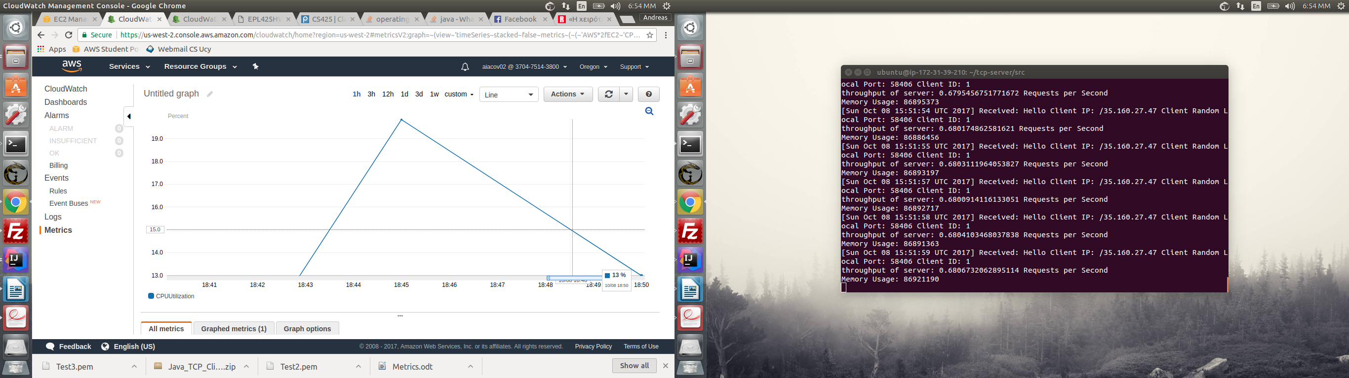

300 requests, 2 users, 2 CPU, 3000 max repetitions – 6 :28pm:

throughput of server: 0.9566596447742267 Requests per Second

Memory Usage: 71855033 bytes

CPU: 16.1%

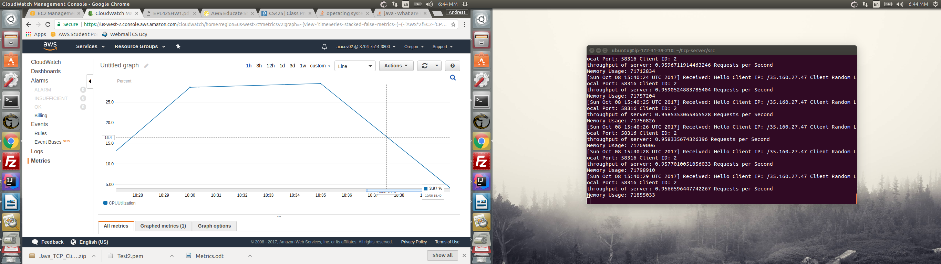

300 requests, 5 users, 2 CPU, 3000 max repetitions – 5 :37pm:

Latency: 4647.433 milliseconds

throughput of server: 1.032644375601486 Requests per Second

Memory Usage: 182042823 bytes

CPU: 18.6%

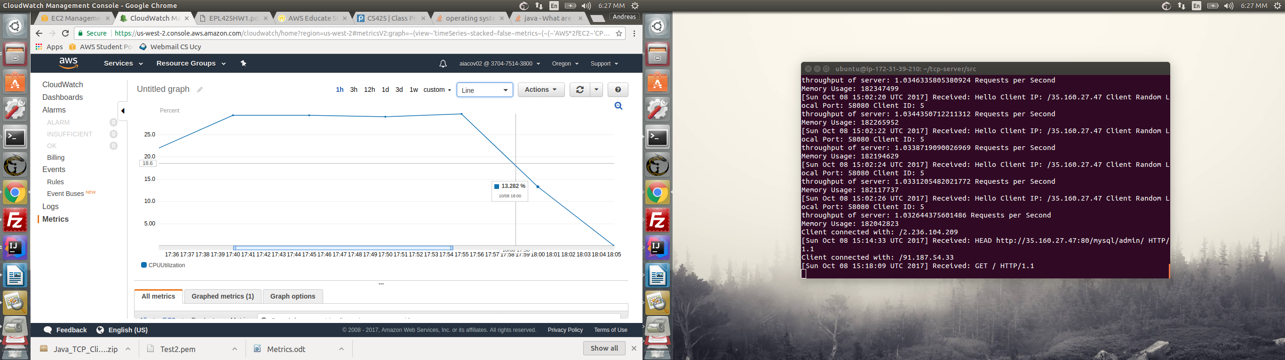

300 requests, 10 users, 2 CPU, 3000 max repetitions:

throughput of server: 1.0504139093447584 Requests per Second

Memory Usage: 146909655 bytes

Latency: 9043.848 milliseconds

CPU: 20.284%

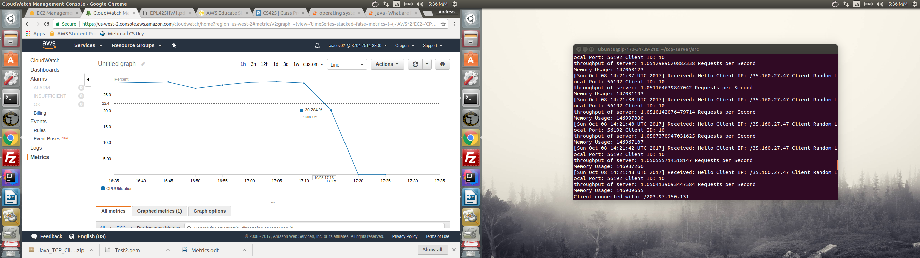

**1.Number of Clients vs Latency(2 core)**

**2.Number of Clients vs Throughput(2 core)**

1.

2.

**3.Throughput vs Average CPU LOAD**

**4.Throughput vs Average Memory Utilization**